Summer Uniform

- White polo shirt

- Grey shorts (Rawcliffes)

- Long grey socks (Rawcliffes)

- Traditional black shoes – with velcro fastenings if possible, or traditional black sandals may be worn.

- Sun hat – light blue (Rawcliffes)

- School book bag (Rawcliffes)

Winter Uniform

- Coram House sweatshirt (Rawcliffes)

- Coram House jogging trousers (Rawcliffes)

- White polo shirt

- Warm waterproof navy coat (Rawcliffes)

- Coram House scarf, gloves & hat (Rawcliffes)

- Traditional black shoes – with velcro fastenings if possible.

- School book bag (Rawcliffes)

NOTES

A simple school uniform is encouraged in the Nursery.

All items should be clearly named.

Extremes of hair fashion are not acceptable. Hair should be neat and tidy and off the collar and face.

The School Outfitters are:
Rawcliffes
617 Roundhay Road
Oakwood
Leeds
LS8 4AR
0113 2494025

The School Shop (located in the Senior School) is open each Wednesday of term, between 2.45 pm and 4.45 pm.

The shop will also be open at various times during the summer holidays.

CORAM HOUSE NURSERY
ACKWORTH SCHOOL

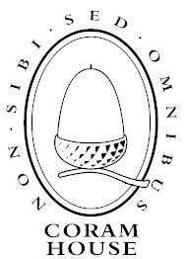

Boys’ Uniform List

All items should be named

